­­­­

Come join us at a community meeting

to support

RICK CARUSO for MAYOR

Monday, October 3, 2022

6:30 p.m.

at the City View Terrace swimming pool

Public Safety Homelessness

Trash dumping Housing Crisis

Corruption & Ethics Small Business

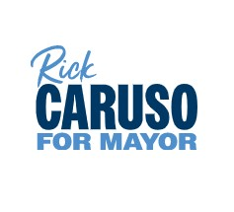

­­­­

Come join us at a community meeting

to support

RICK CARUSO for MAYOR

Monday, October 3, 2022

6:30 p.m.

at the City View Terrace swimming pool

Public Safety Homelessness

Trash dumping Housing Crisis

Corruption & Ethics Small Business

